**Project Report**

**Title of the Project**

**E-Commerce – A STUDY ON THE IMPACT OF ONLINE RETAILING ON THE SECTOR A CASE ON FLIPKART**

**TABLE OF CONTENTS**

**CHAPTER 1 –**

**INTRODUCTION**

* Introducing the topic
* Need of the study
* Literature review
* Objective of the study
* Limitation of the study
* Research Methodology

**CHAPTER 2 –**

CONCEPTUAL FRAMEWORK (National and International Scenario)

* Definition
* Features Advantages and Disadvantages
* Brief Introduction of Flipkart

**CHAPTER 3 –**

* DATA ANALYSIS AND FINDING

**CHAPTER 4 –**

* CONCLUSIONS AND RECOMMENDATIONS

**BIBLIOGRAPHY (OR REFERENCES)**

**INTRODUCTION**

INTRODUCING THE TOPIC –

1. **E-COMMERCE**

Although the terms e-commerce and e-business are often used interchangeably, there are differences. E-commerce is the buying and selling of goods and services on the Internet or other computer network. Any brick and mortar store can become an e-commerce business by adding a virtual storefront with an online catalogue. In most cases, e-business refers exclusively to Internet businesses, but it may also refer to any business that uses Internet technology to improve productivity and profitability.

1. **E-BUSINESS**

Business transactions that involve the exchange of money are covered by the term e-commerce. E-business includes all aspects of running a business that sells goods and services, including marketing, earning and retaining customers, procurement, developing business partners and customer education. In order to be successful, e-commerce and e-businesses must have quality storefronts that are simple to navigate and peruse, with accurate and thorough catalogue information. E-business became an extension of e-commerce to encompass all aspects of businesses that function online. E-business involves e-commerce, but e-

Commerce does not cover all aspects of e-business.

1. **BUSINESS MODELS** E-Commerce or Electronics Commerce business models can generally be categorized in the following categories:-

* Business - to - Business (B2B)
* Business - to - Consumer (B2C)
* Consumer - to - Consumer (C2C)
* Consumer - to - Business (C2B)
* Business - to - Government (B2G)
* Government - to - Business (G2B)
* Government - to - Citizen (G2C)

**Business - to - Business (B2B)**

Website following B2B business model sells its product to an intermediate buyer who then sells the product to the final customer. As an example, a wholesaler places an order from a company's website and after receiving the consignment, sells the end product to final customer who comes to buy the product at wholesaler's retail outlet.

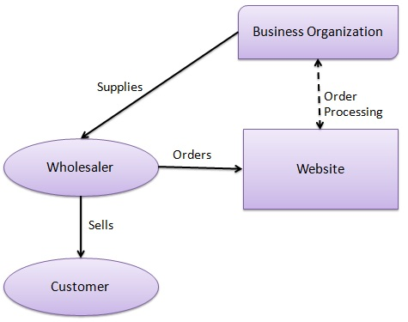

**Business - to - Consumer(B2C)**

Website following B2C business model sells its product directly to a customer. A customer can view products shown on the website of business organization. The customer can choose a product and order the same. Website will send a notification to the business organization via email and organization will dispatch the product/goods to the customer.

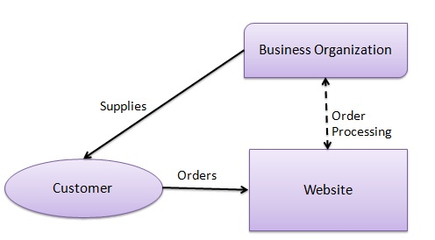

**Consumer - to - Consumer (C2C)**

Website following C2C business model helps consumer to sell their assets like residential property, cars, motorcycles etc. or rent a room by publishing their information on the website. Website may or may not charge the consumer for its services. Another consumer may opt to buy the product of the first customer by viewing the post/advertisement on the website.

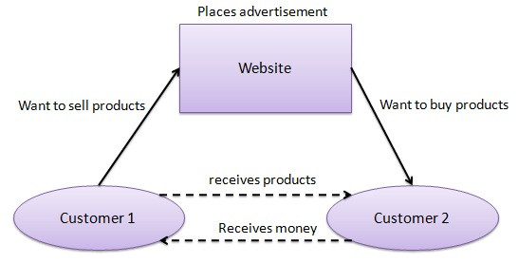

**Consumer - to - Business (C2B)**

In this model, a consumer approaches website showing multiple business organizations for a particular service. Consumer places an estimate of amount he/she wants to spend for a particular service. For example, comparison of interest rates of personal loan/ car loan provided by various banks via website. Business organization who fulfills the consumer's requirement within specified budget approaches the customer and provides its services.

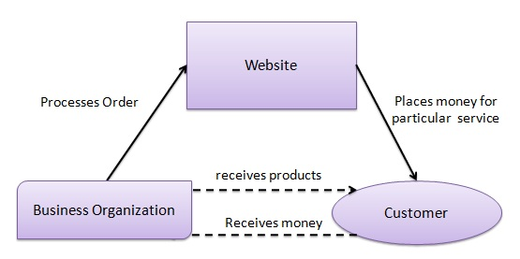

**Business - to - Government (B2G)**

B2G model is a variant of B2B model. Such websites are used by government to trade and exchange information with various business organizations. Such websites are accredited by the government and provide a medium to businesses to submit application forms to the government.

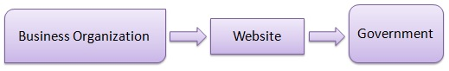

**Government - to - Business (G2B)**

Government uses B2G model website to approach business organizations. Such websites support auctions, tenders and application submission functionalities.

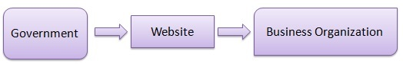

**Government - to - Citizen (G2C)**

Government uses G2C model website to approach citizen in general. Such websites support auctions of vehicles, machinery or any other material. Such website also provides services like registration for birth, marriage or death certificates. Main objectives of G2C website are to reduce average time for fulfilling people requests for various government services.

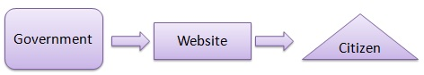

**NEED OF THE STUDY (E-COMMERCE)**

**1.     Exploitation of New Business**

Broadly speaking, electronic commerce emphasizes the generation and exploitation of new .business opportunities and to use popular phrases: “generate business value” or “do more with less”.

**2.     Enabling the Customers**

Electronic Commerce is enabling the customer to have an increasing say in what products are made, how products are made and how services are delivered (movement from a slow order fulfillment process with little understanding of what is taking place inside the firm, to a faster and rt1ore open process with customers having greater control.

**3.     Improvement of Business Transaction**

Electronic Commerce endeavors to improve the execution of business transaction over various networks.

**4.     Effective Performance**

It leads to more effective performance i.e. better quality, greater customer satisfaction and better corporate decision making.

**5.     Greater Economic Efficiency**

We may achieve greater economic efficiency (lower cost) and more rapid exchange (high speed, accelerated, or real-time interaction) with the help of electronic commerce.

**6.     Execution of Information**

It enables the execution of information-laden transactions between two or more parties using inter connected networks. These networks can be a combination of ‘plain old telephone system’ (POTS), Cable TV, leased lines and wireless. Information based transactions are creating new ways of doing business and even new types of business.

**7.     Incorporating Transaction**

Electronic Commerce also inco11'orates transaction management, which organizes, routes, processes and tracks transactions. It also includes consumers making electronic payments and funds transfers.

**8.     Increasing of Revenue**

Firm use technology to either lower operating costs or increase revenue. Electronic Commerce has the Potential to increase revenue by creating new markets for old products, creating new information-based products, and establishing new service delivery channels to better serve and interact with customers. The transaction management aspect of electronic commerce can also enable firms to reduce operating costs by enabling better coordination in the sales, production and distribution processes and to consolidate operations arid reduce overhead.

**9.     Reduction of Friction**

Electronic Commerce research and its associated implementations is to reduce the “friction” in on line transactions frictions is often described in economics as transaction cost. It can arise from inefficient market structures and inefficient combinations of the technological activities required to make a transaction. Ultimately, the reduction of friction in online commerce will enable smoother transaction between buyers, intermediaries and sellers.

**10.   Facilitating of Network Form**

Electronic Commerce is also impacting business .to business interactions. It facilitates the network form of organization where small flexible firms rely on other partner, companies for component supplies and product distribution to meet changing customer demand more effectively. Hence, an end to end relationship management solution is a desirable goal that is needed to manage the chain of networks linking customers, workers, suppliers, distributors and even competitors. The management of "online transactions" in the supply chain assumes a central roll.

**11.   Facilitating for Organizational Model**

It is facilitating an organizational model that is fundamentally different from the past. It is a control organization to the information based organization. The emerging forms of techno-organizational structure involve changes in managerial responsibilities, communication and information flows and work group structures.

**LITERATURE REVIEW**

Several researchers have carried out studies in their effort to examine consumers ‘online buying behavior. For example, Bellman et al (1999) investigated various predictors for whether an individual will purchase online. These authors concluded that demographic variables, such as income, education and age, have a modest impact on the decision of whether to buy online, whereas the most important determinant of online shopping was previous behavior, such as earlier online purchases. This is consistent with Forrester Research which proved that demographic factors do not have such a high influence on technology as the consumers ‘attitudes do (Modal, 2000). Stein field and Whitten (1999) suggested that the combination of the Internet, plus physical presence, provides more opportunities to capture business than the online-only presence, because they can provide better pre-purchase and post-sales services to lower consumer transaction cost and build trust in online stores. However, it is worth mentioning that beliefs and attitudes that are found in the stage prior to the adoption of e-commerce are different to those in the ―post-adoption‖ stage (Geffen et al, 2003; Venkatesh and Brown, 2001; Yu et al, 2005.

**OBJECTIVE OF STUDY**

* To find the factors that leads a website user to return to or recommend the website Flipkart.com
* To discover the key factors that influence online buying behaviour of consumers in India
* To identify who are the online shoppers in terms of demography
* To understand the customer awareness on Flipkart.com
* To determine the factors responsible for customer satisfaction

**LIMITATIONS OF THE STUDY**

No research is complete without admitting the limitations that was faced while conducting a study which will contribute to present learning. This study too like the others have certain constrains which has been discussed below.

* The study was restricted to Bangalore city only
* The study is mainly concentrated on Flipkart.com
* The sample of the size will be limited to time and resources
* The information will be collected valid until there is no any technical change or any innovation
* The result is assuming that respondents have given accurate information

**RESEARCH METHODOLOGY**

**AREA OF STUDY –**

B2C Model of E-Commerce taking the example of www.flipkart.com which is our case study of this project pertaining to one of the models (B2C) of E-Commerce and the main crux of this study will be to see how www.flipkart.com has utilized the B2C Model to revolutionize E-Commerce in India.

The Organization, which I have selected for my Study, is “Flipkart.com” an Emerging Indian online mega store. I would be studying the strategies that the portal have used to attract Indian masses, so as to give them the total online shopping experience, the portal offers an unique strategy towards the masses to make payment modes like Cash & Card on delivery, which invariably helps the masses to avoid the hassle of making online payments, as the credit card penetration in India

is very low, &people are reluctant to make online payments more to do with the Indians psyche. Since portals are giving a customized offering to the masses i.e rite from the wider product portfolio to payment options, its making very convenient for the users to have a online shopping experience hassle free. Flipkart has followed the same business model as of Amazon.com, i.e starting from selling books therefore we can call it as “ Flipkart - The Amazon of India “, however Flipkart is now Regional based E-business portal i.e only targeting Indian Market. More Interesting is that, the minds that worked to start Flipkart are also the Ex. Amazon Employees.

Flipkart.com is an Indian based e-commerce company started by Binny Bansal and Sachin Bansal, who previously worked at Amazon.com. Post their experience, they ventured into a similar e-business idea and launched it in India. Flipkart.com works with the aim of making products and goods easily available at the doorsteps of anyone who has Internet access. Flipkart.com started off from selling books in 2007, based in Bangalore, and entered then consumer electronics category with the launch of mobile phones, in September 2010. Since then it kept on adding more new products categories including books, mobiles, computers, cameras, home & electronic gadgets& appliances, In addition to these very Recently, Flipkart.com has also widened its foray by entering into the emerging digital content market with the recent launch of Flyte, the digital music store & is still continuing to enlarge its product portfolio. It is now one of the leading e-commerce players in India, currently ranked no.1 online shopping site in India, spread in 37 cities, with 11.5 million plus book titles, 14 different categories, 26 million plus registered users and sale of 100000 items a day. It provides online shoppers a memorable online-shopping experience because of its innovative services like:

• Cash on Delivery,

• 30-day replacement policy,

• Easy Monthly Instalment options (EMI),

• Free shipping

• Discounted prices & deals

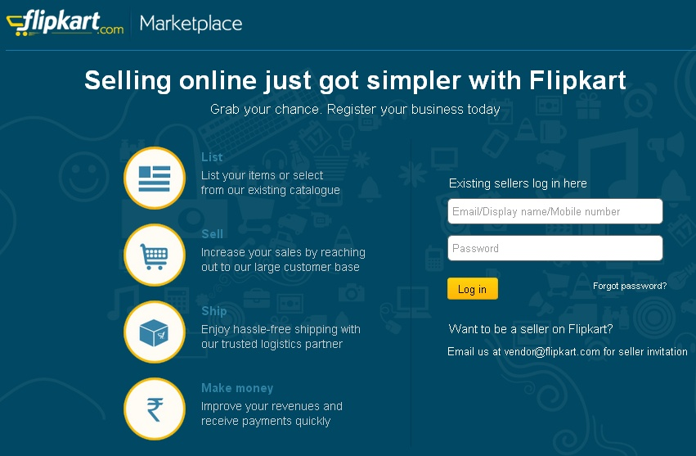

**TYPE OF CASE STUDY –**

1. Flipkart’s revolutionary workings which has completely overhauled purchase of products from physical presence in the market to the purchase of products Online, utilising the B2C model of E-Commerce;
2. Analysis and Trends of change in the Market induced by Flipkart.

**TOOLS FOR DATA COLLECTION:–**

Using various survey reports conducted by Flipkart.com for the betterment of Customer service.

**METHOD OF ANALYSIS –**

Comparison of situations using Graph Analysis and Percentage Analysis.

**TABLES**

**Table 1:- *Some household types and their affinity with b2c e-commerce.***

Household type Affinity with b2c e-commerce

|  |  |
| --- | --- |
| 1. Young adults (< 30 years) | Skilled, frequently using the Internet, eager to know new things but  with limited financial resources; not yet regular Internet shoppers,  but likely to be so in the future, especially when living in rural areas. |
| 2. The elderly (> 60 years) | Insufficient skills, sometimes with financial means and lacking certain physical abilities, but not at all time-pressed; hence limited involvement in b2c e-commerce, which may gradually change over in the next two decades, especially when living in rural areas. |
| 3. Time-pressed families | Highly skilled, double-income, time-pressured households with  children and some affinity with new technologies; potential or present  Internet shoppers, especially when living in rural areas. |
| 4. ‘Active, on-the-go-lifestyles’ | Highly skilled, high-income, time-pressured professionals with a high affinity for new technologies; potential or present Internet shoppers, especially when living in rural areas. |

**Table 2:-*Transaction cost reductions due to e-commerce.***

|  |  |  |  |
| --- | --- | --- | --- |
|  | Consumers (buyers) | Businesses (suppliers) | Advantages of e-commerce |
| Contact | Search for product  alternatives, become aware  of needs and possibilities to fulfiII them, match alternatives,  and evaluate outcomes. | Look for selling  alternatives, consider  manifest or potential  needs of clients, and  determine their  capacity to fulfiII  these needs. | Enhanced access to  information implies better  search, matching and evaluation possibilities.  Efforts to enhance customer  loyalty may reduce this  advantage, however. |
| Contract | Negotiate the terms of a transaction, draft a  preliminary contract, anticipate possible future  problems, and propose changes in the contract. |  | Shift of administrative  costs from sellers to  buyers. Online  planning systems reduce  costs at his stage. |
| Control | Monitor the realization of the transaction process,  compare with contract details. Deviations lead to  haggling, adjustment of contracts, sanctions or  third-party mediation. |  | More information available  through online control  systems, e.g. tracking-and tracing.  In case of  opportunistic behaviour,  e-commerce is not a  sufficient tool to handle problems. |
| During the  entire process | Both parties invest time, effort and money in  preventing misunderstandings, mistakes and  misspecifications, incomplete fine-tuning  or applications. |  | More and better (interactive)  information facilitates  ongoing communication. |

*Source*: adapted from Nooteboom (1994), pp. 32–33.

**CHAPTER 2**

CONCEPTUAL FRAMEWORK / NATIONAL AND INTERNATIONAL SCENARIO

NATIONAL SCENARIO -

Flipkart has worked wonders in the field of E-Commerce, wholly revolutionising the way Indians purchased products, that too directly from the conglomerates themselves. This was brought about by a sound Finance System.

Initially, the founders had spent INR4lakh to set up the business. Flipkart has later raised funding from venture capital funds Accel India (US$1 million in 2009) and Tiger Global (US$10 million in 2010 and US$20 million in June 2011). On 24 August 2012, Flipkart announced the completion of its 4th round of $150 million funding from MIH (part of Naspers Group) and ICONIQ Capital. The company announced, on 10 July 2013, that it has raised an additional $200 million from existing investors including Tiger Global, Naspers, Accel Partners and Iconiq Capital.

Flipkart's reported sales were INR40 million in FY 2008–2009, INR200 million in FY 2009–2010and INR750 million for FY 2010–2011. In FY 2011–2012, Flipkart is set to cross the INR5 billion (US$100 million) mark as Internet usage in the country increases and people get accustomed to making purchases online. Flipkart projects its sales to reach INR10 billion by year 2014. On average, Flipkart sells nearly 20 products per minuteand is aiming at generating a revenue of INR50,000 crore (US$.8 billion) by December 2015.

On November 2012, Flipkart became one of the companies being probed for alleged violations of FDI regulations of the Foreign Exchange Management Act, 1999

In July 2013, Flipkart raised USD 160 million from private equity investors, taking the total to USD 360 million in its recent fund raising drive to build and strengthen technology and bolster its supply chain.

In October 2013, it was reported that Flipkart had raised an additional $160 million from new investors Dragoneer Investment Group, Morgan Stanley Investment Management, Sofina SA and Vulcan Capital with participation from existing investor Tiger Global. With this, the company has raised a total $360 million in its fifth round of funding, the largest investment raised by an Internet company in India, emulating InMobi’s $200 million investment from Softbank in September 2011.

The company valued at approx. US$15.5 billion (May 2015), and plans to use the capital raised to improve its technology and supply chain capabilities, enhance its end user experience and for hiring.

India's e-commerce market was worth about $2.5 billion in 2009, it went up to $6.3 billion in 2011 and to $14 billion in 2012. About 75% of this is travel related (airline tickets, railway tickets, hotel bookings, online mobile recharge etc.). Online Retailing comprises about 12.5% ($300 Millionas of 2009).

India has close to 10 million online shoppers and is growing at an estimated 30% CAGR vis-à-vis a global growth rate of 8–10%. Electronics and Apparel are the biggest categories in terms of sales.

India's *retail market* is estimated at $470 billion in 2011 and is expected to grow to $675 Bn by 2016 and $850 Bn by 2020, – estimated CAGR of 7%. According to Forrester, the e-commerce market in India is set to grow the fastest within the Asia-Pacific Region at a CAGR of over 57% between 2012–16.

INTERNATIONAL SCENARIO –

Flipkart’s reach has not yet reached the International market so we cannot comment on its International Scenario but the management has plans of extending its business to the South East Asian region.

**The Change from traditional commerce to E-Commerce**

For nearly 25 years, Dinesh Chopra lived with a locational handicap. Chopra sells computer parts, electronic gadgets and accessories from his outlet in Nehru Place — an assembly of several four-storey buildings. Although Asia's largest computer market registers thousands of footfalls every day, only a fraction brave the filth and dilapidation to climb up. "I'm on the first floor and that's my weakness," says Chopra, director, Softek Surya. "I don't get regular walking customers."

But Chopra does not mind anymore. "Now, they land on my shop via online marketplaces," he smiles. Softek is a registered seller on five online marketplaces, including eBay and Flipkart. "About 35 per cent of my marketplace buyers are from South India, who have never seen my shop," he says. His annual sales have rocketed from Rs 14 crore in 2010-11 to Rs 60 crore now; and 70 per cent of it is from online marketplaces, which are adding "muscle to business".

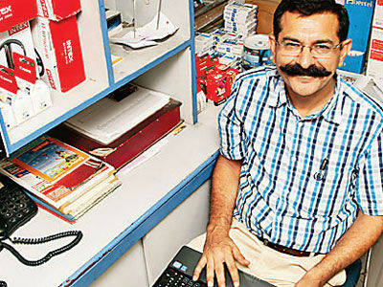

Chopra is a prime example of online marketplaces — branded e-tailers who host sellers, and connect them to buyers for a commission — empowering a small business to scale up.

An example of another kind of empowerment they are enabling is India Trend, which is in business only because of online marketplaces. Seven years ago, Parul Arora Mittal and her mother "tried their luck" by putting 20 pieces of jewellery on eBay. All were sold in a week. Today, Mittal's small operation exports handmade, alloy-metal jewellery, via eBay. "We never had the resources to set up a physical store," says the 30-year-old. Now, she has no reason to. "Since then, I have never even thought of a physical store. The online marketplace is my business place." And their numbers are increasing.

Amazon is the latest, launching its online marketplace in India in June. Globally, the world's largest retailer earns 40 per cent of its 2012 revenues of $61 billion (Rs 3,66,000 crore) by selling other people's goods.

Sensing the groundswell and business logic even **Flipkart, India's largest online retailer, started selling goods of other sellers — the online marketplace model — along with its own goods.** "It's the right time as we have now built the Flipkart brand," says its co-founder & CEO Sachin Bansal, adding the online marketplace is the "right model for India". Such moves by e-commerce players is opening up a world of possibilities for small entrepreneurs like Chopra and Mittal.

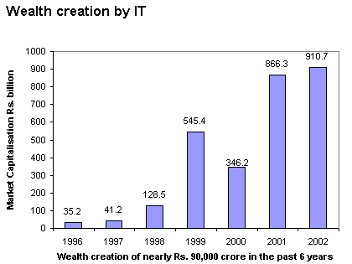

The figure above clearly shows the meteoric rise of E-Commerce in Market Capitalisation by Retail stores in the new Millenium.

It is all because of online shopping sites such as e-bay, FLIPKART, Amazon, etc.

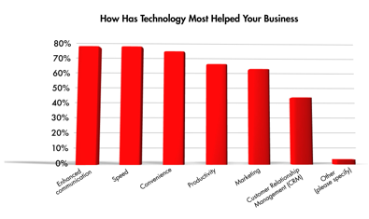

This is a survey conducted to find out how E-Commerce has impacted businesses in India. It clearly shows increase of an average of 70% in all the categories of change, thus, emphasising on the fact of the Rise and Rise of E-Commerce, and its Main Player, **FLIPKART**, in India.

**CHAPTER 3**

**CAPITAL ANALYSIS AND FINDING**

This chapter aims obtain the objective of the study by critically analyzing the qualitative data through thoroughly examining the interviewee‘s responses and beliefs. This has been achieved through evaluating the most relevant responses by the participants. The data has been analysed and discussed by comparing the comments made by the respondents with the literature review keeping in mind the research objective of the study. Thus, the rationale of this analysis is based on the personal answers provided by the respondents. An appropriately designed questionnaire was used to collect the primary data for the study. The data for 100 respondents was organized systematically in tables and graphs and then was subjected to analysis using appropriate statistical tools. The results of the analysis are presented in the following section in order to assess the customer perception towards online shopping on Flipkart.com in India. Here for analyzing, we are considering two factors. That is:

* Demographical factors
* Behavioural factors

Demography

1. **Age Group:**

**Table: Age wise respondents**

|  |  |  |  |  |  |
| --- | --- | --- | --- | --- | --- |
|  | **15-25** | **25-35** | **35-45** | **45& above** | **Total** |
| **No. of Respondents** | **63** | **24** | **12** | **1** | **100** |
| **Percentage** | **63** | **24** | **12** | **1** | **100** |

**Graph: Age wise respondents**

**Analysis and Interpretation:**

Below figure shows that 63% respondents are between 15-25 years old, 24% respondents are between 25-35 years old, 12%respondents between 35-45 years old, and 1% respondents are between 45& above. Overall result shows that between all of the respondents who has age between 15 to 35 years (63%+24%=87%) people are more familiar to shop online on my target population.

**2. Gender of Respondents**

**Table: Gender wise respondents**

|  |  |  |  |
| --- | --- | --- | --- |
|  | **Male** | **Female** | **Total** |
| **Responses** | **58** | **42** | **100** |
| **Percentage** | **58** | **42** | **100** |

**Graph: Gender wise respondents**

**Analysis and Interpretation:**

According to demography profile, in this study 58% male and 42% female respondents are part of my target population and they help me to fulfil my questionnaire from different area of Bangalore city. From these groups total respondents are 100. So, according to the survey result, the male respondents are more and can be told that they interested to shop online than female, even though both of them shop online.

1. **Occupation**

**Table: Occupation wise respondents**

|  |  |  |  |  |  |
| --- | --- | --- | --- | --- | --- |
|  | **Business person** | **Housewife** | **Salaried** | **Student** | **Total** |
| **No. of Respondents** | **8** | **7** | **46** | **39** | **100** |
| **Percentage** | **8** | **7** | **46** | **39** | **100** |

**Graph: Occupation wise respondents**

**Analysis and Interpretation:**

In this survey, 46% of the respondents are salaried and 39% are students. So they both together made majority of respondent‘s percentage (85%). 8% are business persons and 7% are House wife. Salaried persons and students will always look for new technologies and new services which make them more comfort.

**4. Annual Income:**

**Table: Income wise respondent**

|  |  |  |  |  |
| --- | --- | --- | --- | --- |
|  | **0-3L** | **3-6L** | **6-9L** | **9& above** |
| **No. of Respondents** | **60** | **23** | **13** | **4** |
| **Percentage** | **60** | **23** | **13** | **4** |

**Graph: Income wise respondents**

**Analysis and Interpretation:**

Since 39% of this survey is students most of them are of 0-3L

income range, ie 60%. 23% of them are in 3-6L income range, 13% in 6-9L and 4% is 9 & above.

**5. Educational Qualification**

**Table: Educational wise respondent**

|  |  |  |  |  |
| --- | --- | --- | --- | --- |
|  | **Graduate** | **Post Graduate** | **SSC or Equivalent** | **Others (Phd)** |
| **No. of Respondents** | **63** | **36** | **0** | **1** |
| **Percentage** | **63** | **36** | **0** | **1** |

**Graph: Educational wise respondent**

**Analysis and Interpretation:**

All of them in this survey are graduate and above qualified peoples only. Among these 63%are graduates, 36% are post graduates and one person is PhD.

**Behavioural factors:**

**6. Frequency of purchase from online**

**Table: online shopping usage**

|  |  |  |  |  |  |  |
| --- | --- | --- | --- | --- | --- | --- |
|  | **Always** | **Often** | **Sometimes** | **Seldom** | **Never** | **Total** |
| **Male** | **5** | **21** | **29** | **3** | **0** | **58** |
| **Female** | **4** | **14** | **23** | **1** | **0** | **42** |
| **Total** | **9** | **35** | **52** | **4** | **0** | **100** |

**Graph: online shopping usage**

**Analysis and Interpretation:** More than half of them use online shopping sometimes, ie 52%. People who always and mostly shop through online shopping are also good in number, 9 and 35, together 44%. And who use online shopping rarely is very less in number 4%. Since only 44% are mostly using this, there is a wide space to fill and to make online shopping a great success. And there is not much gender difference in online shopping, which means both males and females enjoying online shopping and its benefits.

7. This survey is conducted on those people who do online shopping and are aware of Flipkart.

So everyone answered **‘YES’** for **Question no.7.**

**8. Modes of awareness about Flipkart**

**Table: Modes of awareness about Flipkart**

|  |  |  |  |  |  |  |  |
| --- | --- | --- | --- | --- | --- | --- | --- |
|  | **Word of Mouth** | **Advertisements** | **Blog Recommendations** | **Links from other Websites** | **Promotional Emails** | **Search Engines** | **Total** |
| **No. of Respondents** | **39** | **22** | **2** | **15** | **5** | **17** | **100** |
| **Percentage** | **39** | **22** | **2** | **15** | **5** | **17** | **100** |

**Graph: Modes of awareness about Flipkart**

**Analysis and Interpretation:**

Most of them are aware about Flipkart through word of mouth (39%) followed by television and online advertisements (22%). Customers got aware through blog recommendations (2%) and promotional e-mails (5%) are very less in number. This means a good communication about Flipkart is going on through friends and families, which proves that word of mouth strategy by them is the most successful means of making people aware about their products. Success can only be gained through delighted customers who act as advocates for their products and there is a wide scope of other digital advertisement techniques like search engine marketing,

Email marketing, providing links and blog recommendations in order to make more customers.

**9. Frequency of Using Flipkart.com while online Purchasing:**

**Table: Frequency of Using**

|  |  |  |  |  |  |
| --- | --- | --- | --- | --- | --- |
|  | Every Time | Occasionally | Most of the Time | Hardly Ever | Total |
| No. of Respondents | 17 | 45 | 32 | 6 | 100 |
| Percentage | 17 | 45 | 32 | 6 | 100 |

**Graph: Frequency of Using**

**Analysis and Interpretation:**

Here on this survey 17% are always choosing Flipkart for online shopping, while 45% are using it occasionally. Hardly ever using members are very less, and 32% are using it most of the time. Since more than half of them prefer Flipkart while thinking of online shopping, it means branding had done successfully by them either through advertisements, services or providing good experience to customers.

**10. Category that mostly prefer to buy from Flipkart.com**

**Table: Category mostly prefer to buy from Flipkart**

|  |  |  |  |  |  |  |  |
| --- | --- | --- | --- | --- | --- | --- | --- |
|  | **Electronics** | **Apparels & Accessories** | **Books,Movies& Music** | **Statinary** | **Healthcare & Personal Care** | **Home & Kitchen Items** | **Total** |
| **No. of Respondents** | **39** | **20** | **30** | **3** | **4** | **4** | **100** |
| **Percentage** | **39** | **20** | **30** | **3** | **4** | **4** | **100** |

**Graph: Category mostly prefer to buy from Flipkart**

**Analysis and Interpretation:**

Electronic items, Books and Stationery, Apparels & Accessories, cameras, watches and others (bags, belts, etc.) are purchased more. 39% of respondents are preferred to buy Electronics items followed by Books and Stationery (30%) and Apparels and Accessories (20%). Books & stationery and electronics items are more famous among the students and that may be the reason for large purchase of those items from Flipkart.com.

**11. Reason for Customer’s preference on Flipkart.com than Others:**

**Table: Customers expecting feature of Flipkart**

|  |  |  |  |  |  |  |
| --- | --- | --- | --- | --- | --- | --- |
|  | Fast Deliver | Availability | After Sales Service | Easy Payment Options | Portal Features | Total |
| No. of Respondents | 41 | 29 | 8 | 17 | 5 | 100 |
| Percentage | 41 | 29 | 8 | 17 | 5 | 100 |

**Graph: Customers expecting feature of Flipkart**

**Analysis and Interpretation:**

One of the most efficient features in Flipkart is fast delivery when compared to other online shopping websites. So, most of the customers prefer this website for shopping with the perception of quick delivery (41%) and availability of product (29%), followed by easy payment options (17%). And there is a scope of increasing after sales services and portal features when comparing with other features.

**12. Product selection from the categories given by flipkart.com**

**Table: On the basis where product is chosen**

|  |  |  |  |  |  |
| --- | --- | --- | --- | --- | --- |
|  | Rating of the Product | Discounts and Features | Review About the Product | Brand of the Product | Total |
| No. of Respondents | 14 | 48 | 26 | 12 | 100 |
| Percentage | 14 | 48 | 26 | 12 | 100 |

**Graph: On the basis where product is chosen**

**Analysis and Interpretation:**

Customer perception varies while using Flipkart; it is one of the online shopping sites which give high discounts and offers. Most of them in this survey (48%) are looking for good featured product with high discounts while purchasing products from Flipkart. And also customers more often go through the product review (26%) before making their decision to purchase. Product review is a kind of word of mouth strategy where product users leave their review on their experiences with Flipkart. Customers are giving priority to these two features while brand of product (12%) and rating of product (14%) also taken care by some other customers.

**13. Issues faced by customer while shopiing in Flipkart.com**

**Table: Issues faced when purchased from Flipkart**

|  |  |  |  |  |  |  |  |  |
| --- | --- | --- | --- | --- | --- | --- | --- | --- |
|  | Out of Stock | Payment Issues | Replacement Issues | Delay in delivery | Faulty Product | No issues | Others | Total |
| No. of Respondents | 37 | 6 | 6 | 12 | 8 | 30 | 1 | 100 |
| Percentage | 37 | 6 | 6 | 12 | 8 | 30 | 1 | 100 |

**Graph: Issues faced when purchased from Flipkart**

**Analysis and Interpretation:**

In this survey, 30% of customers didn‘t face any of those problems that mentioned, while 37% of customers faced out of stock issue. This is one of serious issue faced by most of customers. Since discounts and features are the one feature that most of the customers looking for and when a good product with high discount is displayed in Flipkart plat form, customers brought it as soon as they could. Thus the products will be out of stocked.

Flipkart started notifying the customers about the product when the stock got available.

Payment issues and replacement issues are less in number (total 12%) since different payment options like EMI options, card payments, Cash on delivery, Wallet payments etc…are provided by Flipkart and customers are satisfied with those.

In case of replacement also only less issues are happened, thus shows most of them are satisfied with that service. Delay in delivery happens because of shipping and courier service issues. It is a problem with supply chain. Mostly it happens in the end part of the supply and in rural areas where courier services are less active. Faulty product issue also happened to 8% of the customers and one of the policies to overcome this issue is 30 days replacement policy of Flipkart.

**14. Recommending Flipkart to Others:**

**Table: Recommending Flipkart to Others:**

|  |  |  |  |
| --- | --- | --- | --- |
|  | Yes | No | Total |
| No. of Respondents | 95 | 5 | 100 |
| Percentage | 95 | 5 | 100 |

**Graph: Recommending Flipkart to Others:**

**Analysis and Interpretation:**

In this survey, most of them (95%) are happy to recommend Flipkart to others like friends and family. And this shows word of mouth publicity is successfully running and this is one of the great advantages for Flipkart.

**15. Customer’s rating about services on Flip[kart.com:**

**Table: Rating The experience from Flipkart**

|  |  |  |  |  |  |  |
| --- | --- | --- | --- | --- | --- | --- |
|  | 1 | 2 | 3 | 4 | 5 | Total |
| No. of Respondents | 7 | 11 | 16 | 49 | 17 | 100 |
| Percentage | 7 | 11 | 16 | 49 | 17 | 100 |

**Graph: Rating The experience from Flipkart**

**Analysis and Interpretation:**

While analysing the rating of experiences, Flipkart provides a good and excellent experiences to most of the customers.

Mode of given data: 4 & Median of given data: 4

49% of customers rated 4 as the experience and more than half of the population (66%) rated4 & 5 as experience

**CHAPTER 4**

**CONCLUSIONS AND RECOMMENDATIONS**

**FINDINGS:**

* There is not much difference in gender for using online shopping.
* Students and salaried persons are most frequent users of Flipkart.
* Frequency of purchase for electronics, books and music, apparels and accessories are more in Flipkart.
* Word of mouth was more influential in promotion as many people were made aware by their friends and family when customers recommend this website to them.
* Highly discounted products got out of stock quickly, since customers purchased it as on as they could when they see high discount on good featured product.
* The services provided by Flipkart are good and even more scope of development is there for increasing the customer strength.
* Digital marketing techniques like search engine marketing, links providing other website and advertisement also functioned well for promotion of this website.
* Fast delivery is one of best service Flipkart is providing.
* Different payment options available in Flipkart made customers more satisfied and comfort for paying while purchasing product.
* Customers feeling more secured when purchasing through Flipkart because of different policies and services they have.
* In comparison with competitors, Flipkart is charging free shipping for the purchase of300 plus rupees, while others free ship the service without any barrier.
* Out of stock is the main issue faced by Flipkart.
* Most of customers have good experience with Flipkart while purchasing products.
* Most of them are satisfied with the services of Flipkart and so that they succeed in retaining the customers.
* Advertising is an important way to have the brand and products familiar to consumers Convenience and time saving are two important factors that customer looking for while purchasing through online.

**RECOMMENDATIONS:**

* Flipkar has successfully placed itself into the prospects mind making it the India‘s largest online store with huge range of products. But it still needs to work on their core competence that is books and stationery items.
* Delivery services can be improved mainly in rural areas by selecting appropriate courier service which has services in customer area for dispatching an item.
* Can make free delivery to all priced products.
* Can include more coupon codes and gift vouchers for increasing the traffic of the customers.
* Out of stock items can made available as soon as possible and intimate the needed customers.
* Should look for International/ Overseas markets or Neighbouring Countries.
* Critical mass of Internet users–Internet users in India is increasing at increasing rate, so Flipkart can target more & more cities i.e not only tier 1 & 2 but also tier 3 & 4cities, which will help generate stronger customer base & more revenues.
* Should clearing focus on the Growing Online Apparel business & it can diversify into apparel category either organically or inorganically by acquiring other portals.
* User Experience: Portal should continuously aim to work to improve the user experience by adding more & more innovative features in the website like virtually shopping basket, virtual trial rooms. In this competitive world to differentiate via user experience, the ultimate winner will be the Indian online consumer.
* Should comprehensively invest into E-CRM & online reputation management.
* Logistics & Supply Chain: can continuously aim to reduce the delivery time cycle.
* Price will still be a factor as amazon being a huge company will use its economies of scale to remove their competitors from the market; therefore they need to be more competitive on that aspect.

**CONCLUSION:**

The thorough study is based on the consumer behaviour analysis which serves a great idea regarding consumer perception when they go for online shopping. In order to satisfy themselves consumer perceive many things before buying products and they will be satisfied if the company meet their expectation. The Overall Brand Value of Flipkart is good, but it is facing some tough competition from its global competitors like Ebay and Amazon. Talking about domestic market i.e India, it is the most superior E-business portal which is aggressively expanding & planting its roots deep into the Indian market & at the same time shifting the mind-set of the people from going &shopping from physical store to online stores, which is magnificent!.Be very focused on consumers and build amazing experiences for the customers.

**Diagrams**

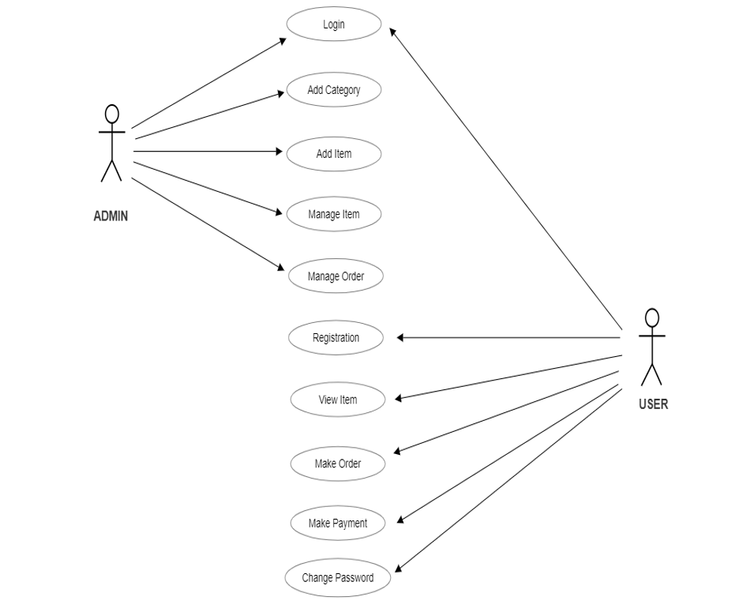

**Use Case Diagram**

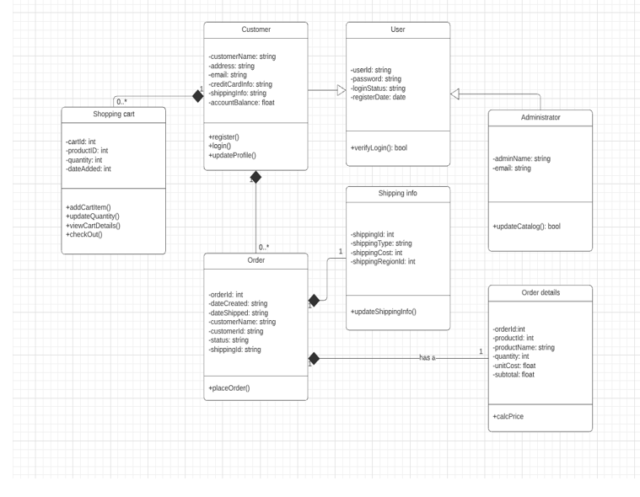

**Class Diagram**

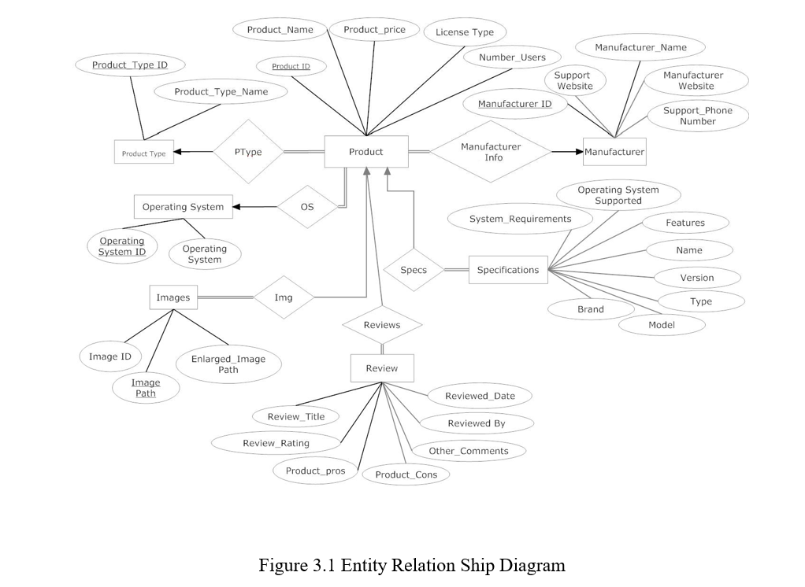

**ER Diagram**

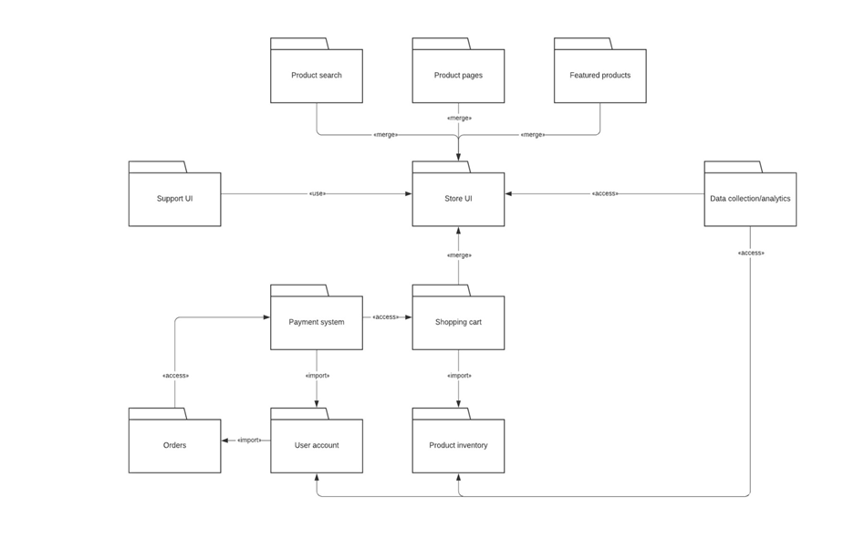

**Package Diagram**

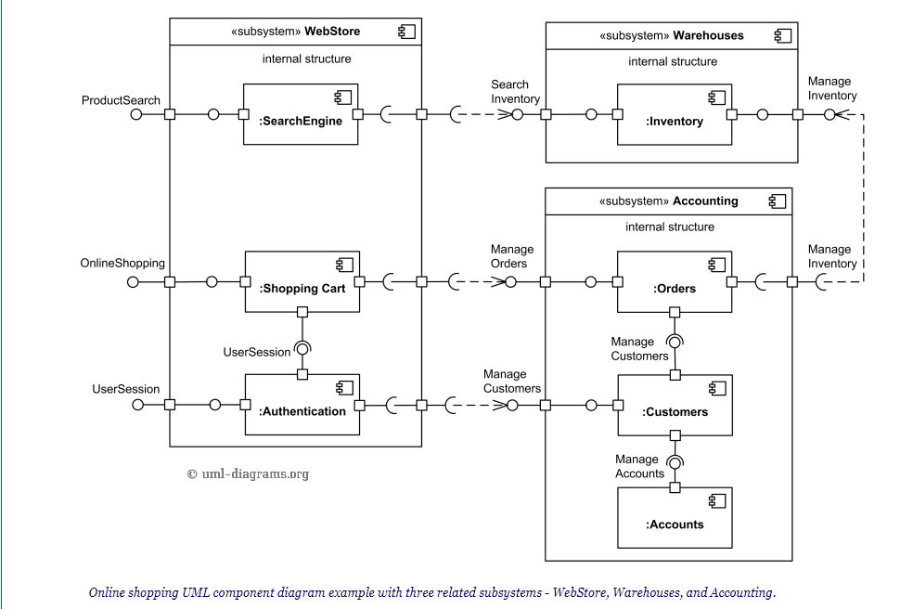

**BIBLIOGRAPHY:**

* [www.flipkart.com](http://www.flipkart.com)
* [www.commodityindia.com](http://www.commodityindia.com)
* [www.marketoperation.com](http://www.marketoperation.com)
* [www.nextbigwhat.com](http://www.nextbigwhat.com)
* [www.britannica.com](http://www.britannica.com)
* [www.ecommerce-land.com](http://www.ecommerce-land.com)
* [www.commodityindia.com](http://www.commodityindia.com)
* [www.marketoperation.com](http://www.marketoperation.com)
* WIKIPEDIA